ABS ECU (Anti-lock Braking System Electronic Control Unit)

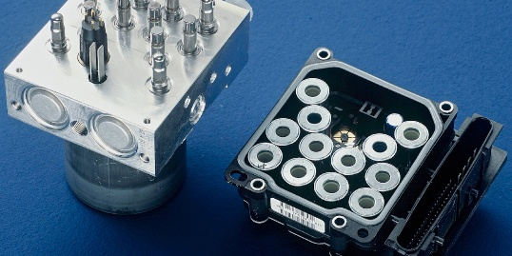
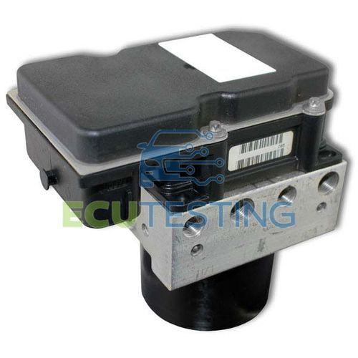
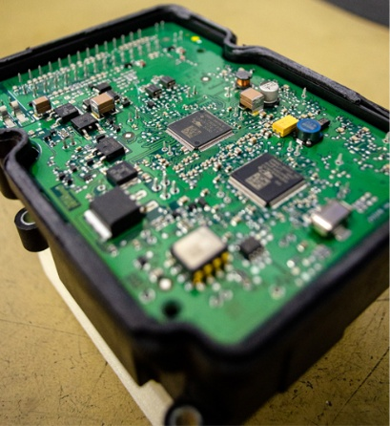

Internal Architecture of ABS ECU:
1. Microcontroller (Core Brain)
- Automotive-grade MCU (Infineon / NXP / Renesas)
- Runs at real-time speeds
- Executes control algorithms every few milliseconds
2. Input Stage (Sensors Interface)
- Takes signals from:
  - Wheel speed sensors
- Includes:
  - Signal conditioning (filters, amplifiers)
  - ADC or digital capture
3. Processing Unit
- Calculates:
  - Wheel speed
  - Acceleration/deceleration
  - Slip ratio
- Decision logic:
  - Is wheel locking?
  - Should pressure be reduced?
4. Output Driver Stage
- Controls:
  - Solenoid valves
  - Pump motor
- Uses:
  - MOSFET drivers
  - PWM signals
5. Communication Interface
- Talks to other ECUs using:
  - CAN Bus
6. Power Management
- Converts 12V battery to:
  - 5V / 3.3V for MCU
- Includes:
  - Voltage regulators
  - Protection circuits
7. Memory
- Flash → program storage
- EEPROM → fault codes (DTCs)
- RAM → runtime data

Safety & Reliability Features
Redundancy
- Multiple checks for sensor validity
Watchdog Timer
- Resets ECU if software hangs
Fail-safe Mode
- Falls back to normal braking if ECU fails
Self-Diagnostics
- Detects:
  - Sensor faults
  - Valve faults
  - Communication errors

ECU + HCU Integration
In modern vehicles:
- ABS ECU is often combined with:
  - Hydraulic Control Unit (HCU)
Called: ABS Module
Software Inside ABS ECU
- Usually built on:
  - AUTOSAR architecture
- Written in:
  - Embedded C
Tasks include:
- Sensor data acquisition
- Control algorithm execution
- Communication handling
- Fault detection

Feature | ABS ECU
Response Time | Extremely fast (ms level)
Type | Hard real-time system
Criticality | Safety-critical
Control Type | Closed-loop control

Core Data Handled by ABS ECU
1. Wheel Speed Data
• Individual speed of each wheel (FL, FR, RL, RR)
• Measured in RPM or km/h
• High-frequency signal from sensors
Primary input for all ABS decisions
2. Wheel Acceleration / Deceleration
• Rate of change of wheel speed
• Detects sudden drops (wheel about to lock)
Equivalent to “trend analysis” in BMS
3. Slip Ratio Data
• Difference between vehicle speed and wheel speed
• Indicates traction condition
• Optimal slip ≈ 10–20%
Key performance parameter
4. Brake Pressure Data
• Hydraulic pressure in brake lines
• Monitored indirectly or via sensors
Used to understand braking force applied
5. Vehicle Speed Estimation
• Derived from wheel speeds
• Sometimes fused with other ECUs
Reference value for slip calculation
6. Valve Status Data
• State of solenoid valves:
- Open / Closed
• Pressure mode:
- Increase / Hold / Decrease
7. Pump Motor Status
• ON / OFF condition
• Current consumption (in advanced systems)
8. Fault & Diagnostic Data
• Sensor faults
• Signal loss
• Electrical faults
• Stored as Diagnostic Trouble Codes (DTCs)
9. Road Condition Estimation Data
• Derived from slip patterns
• Detects:
- Wet road
- Dry road
- Low friction (gravel/ice)
Not direct sensors — calculated data

10. System Status Data
• ABS active / inactive
• Warning light status
• System health

